Brussels, 29 May 2019

Transparency Award Module Compliance Checks 2019

Bilateral Communication on Compliance Issues – Bulgaria
Enhancing Transparency in public spending is a priority goal for the Commission.
The Transparency provisions introduced by the State Aid Modernisation (SAM) address this concern by requiring Member States to publish detailed information on all individual aid awards above € 500.000 as of 1 July 2016. In this context, every year the Commission verifies completeness and accuracy of the information published under the transparency requirements through the compliance checks.
The Commission carried out a first exercise in 2017 concerning State aid measures approved after the 1 July 2016 and for which expenditure was reported for the year 2016 in the context of the 2017 Reporting exercise. Main results were presented during the Transparency Steering Group (TSG) held in Brussels on 23th November 2017 and a questionnaire was sent for clarifications and general comments in March 2018.
This second round enlarges substantially the coverage of the exercise as it investigates compliance for measures approved between 1 July 2016 and 31 December 2017 for which expenditure was reported for the years 2016 and 2017 under the 2017 and 2018 Reporting exercises. In addition, it expands the scope of the compliance checks by including a short descriptive analysis of the main trends in State aid awards and a summary table with performance indicators.

Structure and main findings of the 2019 compliance checks exercise
This questionnaire presents the main findings of the 2019 compliance checks exercise.
Member States are invited to provide further clarifications on the different issues identified and to make general comments and suggestions. In addition, they are kindly invited to communicate if any corrections to figures reported in TAM and/or in the national registry will be applied following this round of compliance checks.
Compliance issues identified in the context of the 2019 compliance checks follow the logic adopted in the previous exercise and are classified in two main categories:
- Compliance issues with respect to the publication obligation;
- Compliance issues with respect to the quality of reporting.
In addition, the 2019 Compliance checks include a third category that groups together cases that could theoretically present possible minor inconsistencies.
Further details and a description of the two classes of issues mentioned above are provided in the dedicated sections of the questionnaire.

Overview: Compliance Performance Indicators
This section provides an overview of the overall situation of each Member State in terms of compliance with the transparency obligations. The Compliance Performance Indicators (CPI) provide a useful benchmark for Member States to identify strengths and areas of improvement for the future.
Key performance indicators
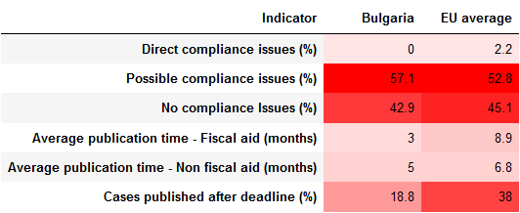
Source: COMP A3 computations.

Compliance issues with respect to the publication obligation
The Commission considers that compliance issues with respect to the publication obligation arise when a Member State fails to publish an aid award under a measure that responds to the two following criteria: (i) the granting act was issued after the 1st of July 2016 and (ii) the reported amount spent in the period of analysis exceeds € 500.000.
In this respect, the compliance issues identified are of two main types:
- Direct compliance issues:
- Possible compliance issues.

  - Direct compliance issues
Direct compliance issues arise when a Member States fails to publish an aid award (i.e. there are no entries in the TAM or in the national registry) under a measure for which the estimated amount spent per beneficiary is equal or higher than € 500.000.
When computing the estimated amount spent per beneficiary, the Commission makes a distinction between State aid measures classified ‘Individual aid within a scheme’ and ‘schemes’. In the former cases, the amount spent per beneficiary automatically corresponds to the amount spent under the measure. In the latter case, the presence of compliance issues can only be established for cases in which the number of estimated beneficiaries is known ex-ante (usually in ranges) and an average amount spent per beneficiary can be computed.
Direct compliance issues were identified for the following schemes:
Direct compliance issues identified
No direct compliance issues were identified as regards your Member State.
Source: COMP A3 computations.
Please indicate for which, if any, of the abovementioned measures, your authorities consider that there is no compliance issue, and explain why:
Click here to enter text.
For each of the remaining measures identified above, please describe the specific difficulties that contributed to the compliance issue and how they will be addressed in the future:

Click here to enter text.

  - Possible Compliance issues
The Commission considers that compliance issues may also arise when the number of beneficiaries is unknown or when the calculated average amount granted per beneficiary is below € 500.000, while there are no corresponding entries in TAM or in the national registry. In those situations, it is indeed not possible to determine with certainty whether none or some of the beneficiaries were granted an amount equalling or exceeding € 500.000.
Possible compliance issues were identified for the following schemes:

Possible compliance issues identified
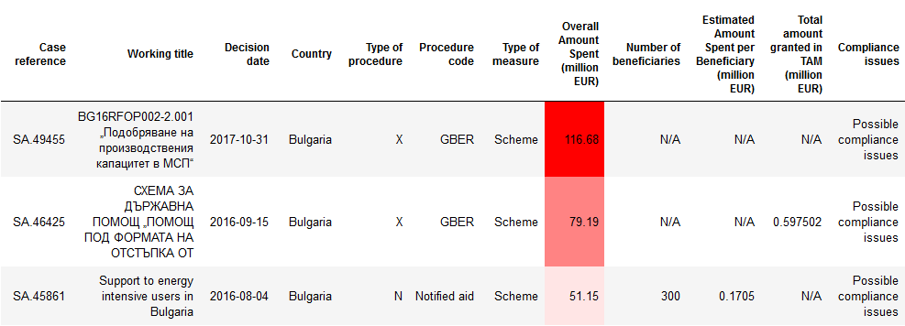
Source: COMP A3 computations.
Please confirm, for each of the abovementioned schemes, that none of the beneficiaries was granted € 500.000 or more. If not, please provide the list of schemes for which corresponding corrections would need to be made.

Click here to enter text.

Please describe, for each of the schemes in which one or more beneficiaries were granted € 500.000 or more, the specific difficulties that contributed to the compliance issue and how they will be addressed in the future:

Click here to enter text.

Compliance issues with regard to the quality of reporting
The Commission considers compliance issues with respect to the quality of reporting to arise when aid awards are published after the deadline for publication (for non-fiscal aid 6 months after the granting date and for fiscal aid 1 year after the ultimate deadline to submit the fiscal declarations).
Here are a few examples of aid awards that have been reported after the deadline:
Aids awards reported after the deadline
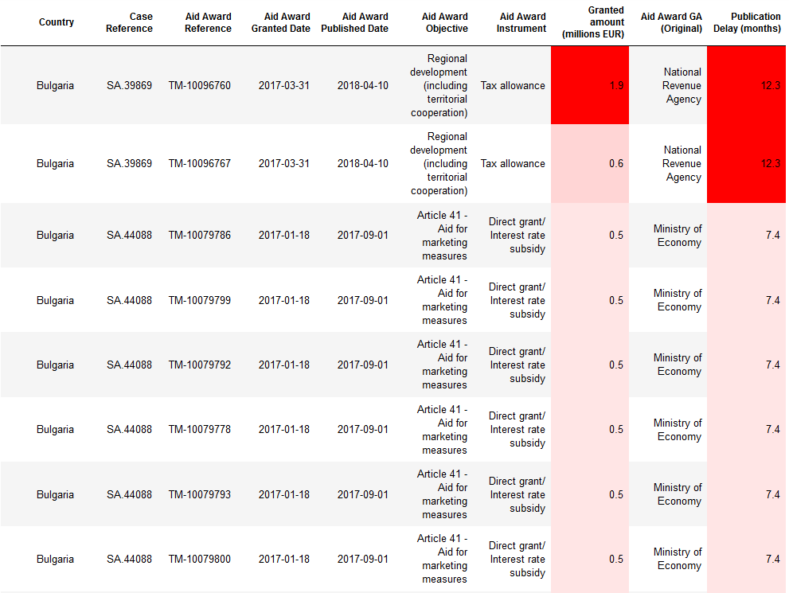

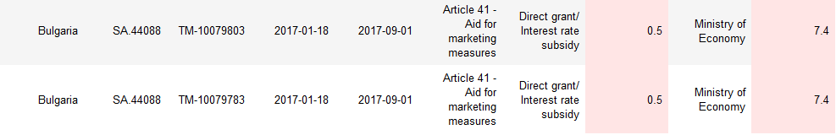
Source: COMP A3 computations.
Please indicate one or more reasons why some or several Granting Authorities did not meet the deadline in the abovementioned cases:

Click here to enter text.

Possible inconsistencies for old cases
Beyond the types of compliance issues identified in sections 2 and 3, the Commission considers that possible inconsistencies could arise for measures whose starting date is prior to the entry into force of the transparency obligations (1 July 2016), but under which aid was paid out in 2016 and/or 2017 and which are, therefore, part of the 2016 and/or 2017 Reporting exercise.
This third type of identified issues and related checks are carried out with precautionary intent to verify that the related granting acts authorizing expenditures falling within the period of analysis were not subject to the transparency obligations.
Possible inconsistencies are, therefore, not part of the Compliance Performance Indicators (CPI).
Here are a few examples of the measures identified as possible inconsistencies:
Possible inconsistencies for old cases
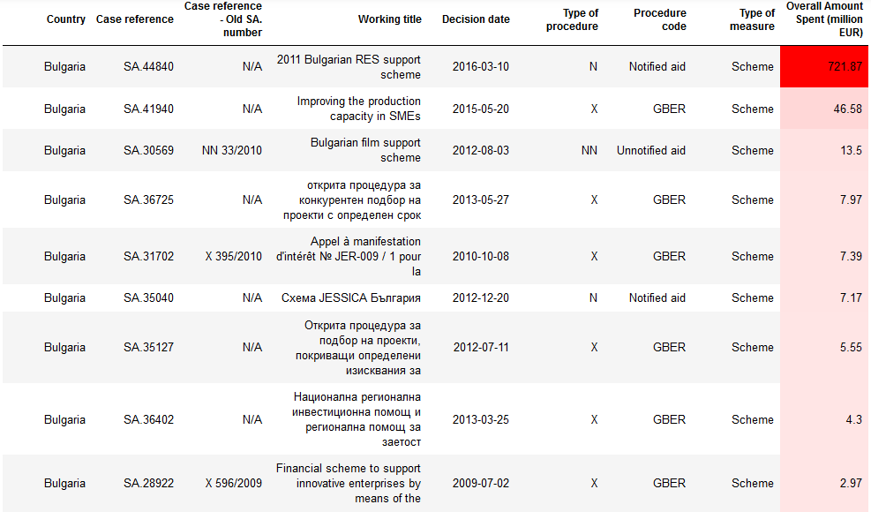

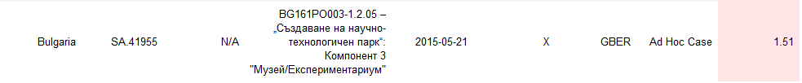
Source: COMP A3 computations.
Please confirm that none of the reported measures falls under the transparency obligations and, if it does, that no individual granting act authorizing the expenditure was issued after 1 July 2016:
Click here to enter text.
Please note in this context that old GBER measures with a duration going beyond 31.12.2014, should have be adapted to the provisions of the 2014 GBER and a new information sheet should have been sent to the Commission, via SANI 2, using the new form in ANNEX 2 of the 2014 GBER. The sheet should indicate if the measure is a prolongation of an existing aid scheme, with/without modifications to comply with the provisions of the 2014 GBER. Therefore, no old GBER aid measure number should appear in the TAM. If this is the case, please check whether you have sent a new summary information sheet for this/these measures.

Descriptive analysis
Transparency data offers the chance to monitor the activity of granting authorities and gather evidence of trends and patterns in State aid awarding behaviours through simple statistical analysis.
In this respect, this section is not meant to provide additional information on the level of compliance, but rather to offer an overview to support Member States in their monitoring activity of granting behaviours.

  - Top biggest beneficiary enterprises
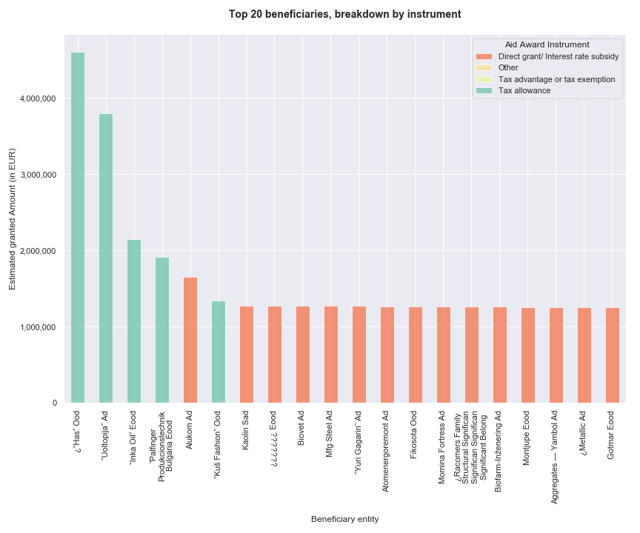
Source: COMP A3 computations.

Please indicate here should you have comments on table 5.1
Click here to enter text.

  - Top granting authorities by amount granted
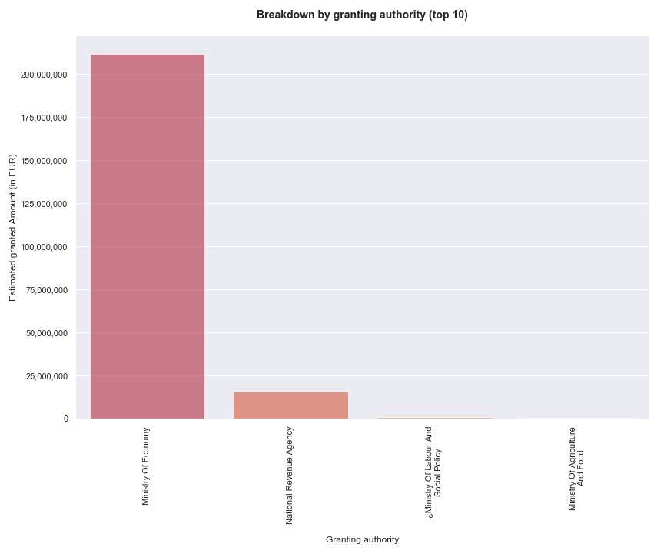
Source: COMP A3 computations.

Please indicate here should you have comments on table 5.2
Click here to enter text.

  - Share of aid granted by firm size
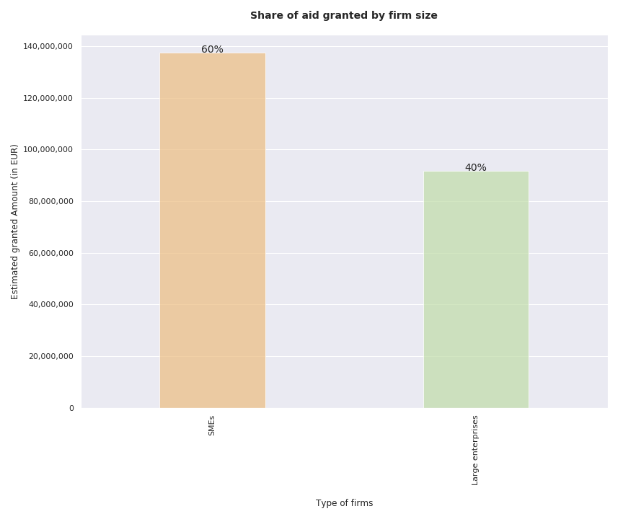
Source: COMP A3 computations.

Please indicate here should you have comments on table 5.3
Click here to enter text.

Prospective part: Improving Compliance with the transparency requirements
  - Improvements to the TAM
Please indicate, if any, possible improvements of the Transparency Award Module that would help improving compliance with the transparency requirements both in terms of publication and quality of reporting:
Click here to enter text.
  - Interpretation of the rules and applicability
Please indicate which elements of the current design of the transparency obligations could be further refined, in your experience, in order to improve compliance:
Click here to enter text.

Special Remarks
No additional remarks were identified as regards your Member State.
Please indicate here should you have comments on the mentioned remarks:
Click here to enter text.

Contact:
GALLI DE PARATESI Davide – State Aid Strategy (A3), +32 2 29 80901
MATHIEU COLLIN Antoine – State Aid Strategy (A3), +32 2 29 88361
CANNAS Giuseppina – State Aid Strategy (A3), +32 2 29 83137
VIDONI Daniele – State Aid Strategy (A3), +32 2 29 68739

Figures are temporary and will be adjusted after clarifications from Member States will be provided, if necessary.
Please note that for Member States not using the TAM it was not possible to compute any figures on average publication time (fiscal and non-fiscal aid) as well as the total share of cases published after the deadline. These countries were also excluded from the corresponding EU average calculations.
Please note that in the 2019 compliance checks, measures approved before 1 July 2016 but for which aid awards in TAM were reported, since the granting act was issued after the entry into force of the transparency obligations, have been included in the analysis. Excluding such aid awards would have reduced the levels of compliance for Member States and produced an overall inaccurate picture. For more accurate information on the threshold date and definition of granting act please refer to the Encoding Guidance in the TAM.
Full list of cases in Annex I.
Full list of cases in Annex II.
The 31st December of the year during which the aid has been granted has been considered.
Please let us know if you want to receive the full list of cases identified under this heading.
Full list of cases in Annex III.
Please note that for Member States not using the TAM and for which it was not possible to retrieve data from the National transparency website, it was not possible to produce any of the graphs in this section.

